Product Hunt.
I want browser act bot that would receive a link from me (it would be “todays’ launches, the link is different every day since it’s a date dependent)
Each page with lunches is an infinite scroll (Until projects of the day are ended. ) so the bot will have to always scroll down until the page stops loading.
For each tool I want a following data (in MD): name of the project, tagline, number of upvotes and website address. Website address is visible upon hover, so the bot can stay on the same page (see gif below)
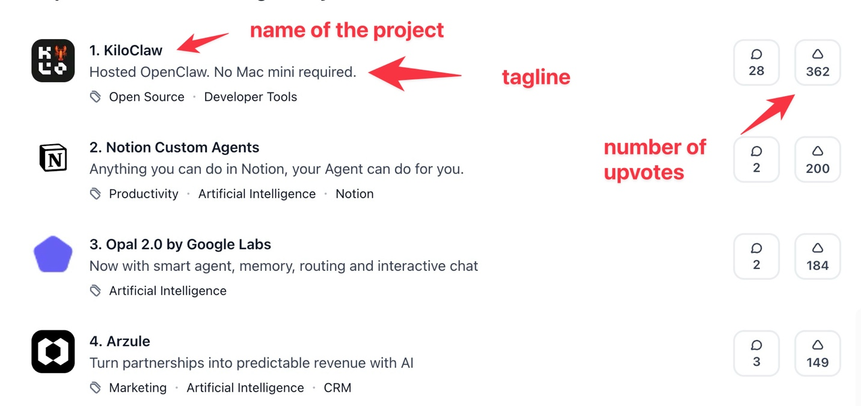



For TAAIFT scraper:

On the homepage there’s
“just released” section, I will want to run the bot once per day and get the data of releases that were launched within the last 24 hours. (it has “released … ago”)
From those launches I want the following data (in MD): name of the project, tagline, number of views and website address. Website address is visible upon hover
